Experiment No 8
Roll No:24141030 Lab: PL-II

Theory:
Introduction to Object-Oriented Programming (OOP)
Object-Oriented Programming (OOP) is a programming paradigm that organizes code around "objects" rather than functions and logic. An object is a self-contained entity that contains both data (attributes) and behaviors (methods). Python is a multi-paradigm language that fully supports OOP.2. Key OOP Concepts
Concept | Description
Class | Blueprint or template for creating objects
Object | Instance of a class (actual entity with data)
Encapsulation | Bundling data and methods; hiding internal details
Inheritance | Creating new classes based on existing classes
Polymorphism | Same method name, different behavior in different classes
Abstraction | Hiding implementation details and showing only functionality

3. Classes and Objects
Class: A user-defined blueprint that defines the attributes and methods that objects of that class will have.
Object: An instance of a class with actual values for the attributes.
class Student: # Class definition
pass
s1 = Student() # Object creation

4. Constructor (__init__ method)
The __init__ method is a special method (constructor) that is automatically called when an object is created. It initializes the object's attributes.
class Person:
def __init__(self, name, age):
self.name = name # Instance attribute
self.age = age

5. Types of Variables
Variable Type | Description | Access
Instance Variable | Unique to each instance; defined in __init__ | Through self or object
Class Variable | Shared by all instances; defined directly in class | Through class name or self
Local Variable | Defined inside a method; exists only there | Only within that method

6. Types of Methods
Method Type | Description | Decorator
Instance Method | Operates on instance; has self | None
Class Method | Operates on class; has cls | @classmethod
Static Method | Independent of class/instance | @staticmethod

7. Inheritance
Inheritance allows a class (child) to inherit attributes and methods from another class (parent).
Benefits of Inheritance:
- Code reusability
- Establishes hierarchical relationships
- Method overriding capability

8. Types of Inheritance
Type | Description | Diagram
Single | One child inherits from one parent | A → B
Multiple | One child inherits from multiple parents | A, B → C
Multilevel | Chain of inheritance | A → B → C
Hierarchical | Multiple children from one parent | A → B, A → C
Hybrid | Combination of multiple types | Complex

9. Method Overriding
When a child class defines a method with the same name as a parent class method, it overrides the parent's method. The child's version is called instead.

10. super() Function
The super() function allows a child class to call methods from its parent class.

11. Encapsulation and Access Modifiers
Encapsulation restricts direct access to an object's data. Python uses naming conventions for access control:
Convention | Access Level | Example
variable | Public (accessible anywhere) | self.name
_variable | Protected (convention - internal use) | self._name
__variable | Private (name mangling - harder to access) | self.__name

12. Polymorphism
Polymorphism allows objects of different classes to respond to the same method call in their own way.
Types:
- Compile-time polymorphism (method overloading) - Python supports through default arguments
- Runtime polymorphism (method overriding) - Fully supported

13. The self Parameter
self is a reference to the current instance of the class. It is automatically passed as the first parameter to instance methods. By convention, it's named self (can be any name, but self is standard).

Programs and Code:

1. Program to create a class and object
class Student:
def display(self):
print("This is a student class")
print("Student class represents a student entity")
s1 = Student()
print(f"Object created: {s1}")
print(f"Type: {type(s1)}")
s1.display()
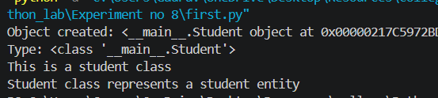
2. Program to demonstrate constructor
class Person:
def __init__(self, name, age):
print(f"Constructor called for {name}")
self.name = name
self.age = age
def display(self):
print(f"Name: {self.name}, Age: {self.age}")
print("Creating objects...")
p1 = Person("Alice", 25)
p2 = Person("Bob", 30)
print("\nDisplaying details:")
p1.display()
p2.display()
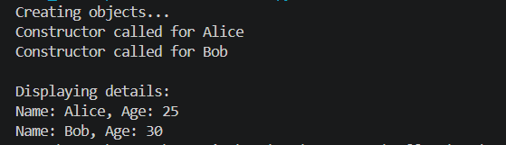
3. Program to demonstrate instance and class variables
class Employee:
company = "ABC Corp"
employee_count = 0
def __init__(self, name, salary):
self.name = name
self.salary = salary
Employee.employee_count += 1
def display(self):
print(f"Name: {self.name}, Salary: {self.salary}, Company: {Employee.company}")

print(f"Initial employee count: {Employee.employee_count}")
e1 = Employee("John", 50000)
e2 = Employee("Jane", 60000)
e1.display()
e2.display()
print(f"Total employees: {Employee.employee_count}")
print(f"Class variable accessed via class: {Employee.company}")
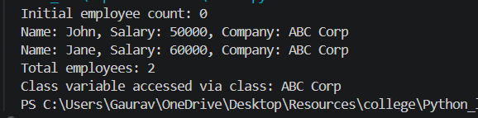
4. Program to demonstrate single inheritance
class Animal:
def __init__(self, name):
self.name = name
def eat(self):
print(f"{self.name} is eating")
def sleep(self):
print(f"{self.name} is sleeping")
class Dog(Animal):
def bark(self):
print(f"{self.name} is barking")
def eat(self):
print(f"{self.name} is eating dog food")
print("=== Single Inheritance ===")
animal = Animal("Generic Animal")
dog = Dog("Buddy")
print("\nAnimal actions:")
animal.eat()
animal.sleep()
print("\nDog actions:")
dog.eat() # Overridden method
dog.sleep() # Inherited method
dog.bark() # Child's own method
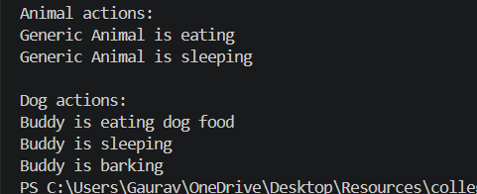
5. Program to demonstrate multiple inheritance
class Father:
def __init__(self):
self.father_skill = "Cooking"
def skills(self):
print(f"Father's skills: {self.father_skill}, Driving")
class Mother:
def __init__(self):
self.mother_hobby = "Reading"
def hobbies(self):
print(f"Mother's hobbies: {self.mother_hobby}, Gardening")
class Child(Father, Mother):
def __init__(self):
Father.__init__(self)
Mother.__init__(self)
self.talent = "Singing
def talents(self):
print(f"Child's talents: {self.talent}, Dancing")
c = Child()
print("Child inherits from both Father and Mother:")
c.skills()
c.hobbies()
c.talents()
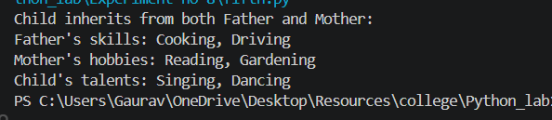
6. Program to demonstrate multilevel inheritance
class GrandParent:
def __init__(self):
self.grandparent_property = "House"
def grandparent_method(self):
print("This is GrandParent class")
print(f"Grandparent property: {self.grandparent_property}"
class Parent(GrandParent):
def __init__(self):
GrandParent.__init__(self)
self.parent_property = "Car"
def parent_method(self):
print("This is Parent class")
print(f"Parent property: {self.parent_property}")
class Child(Parent):
def __init__(self):
Parent.__init__(self)
self.child_property = "Laptop"
def child_method(self):
print("This is Child class")
print(f"Child property: {self.child_property}")
c = Child()
c.grandparent_method()
c.parent_method()
c.child_method()
print(f"\nAll properties: {c.grandparent_property}, {c.parent_property}, {c.child_property}")
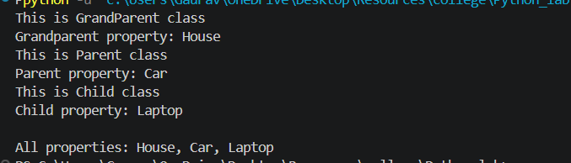
7. Program to demonstrate method overriding
class Shape:
def area(self):
print("Area of shape (to be overridden)")
return 0
def description(self):
return "This is a shape"
class Rectangle(Shape):
def __init__(self, length, breadth):
self.length = length
self.breadth = breadth
def area(self):
return self.length * self.breadth
def description(self):
return f"This is a rectangle with length={self.length}, breadth={self.breadth}"
class Circle(Shape):
def __init__(self, radius):
self.radius = radius
def area(self):
return 3.14159 * self.radius ** 2
def description(self):
return f"This is a circle with radius={self.radius}"
shapes = [Rectangle(5, 3), Circle(4)]
for shape in shapes:
print(f"\n{shape.description()}")
print(f"Area: {shape.area():.2f}")
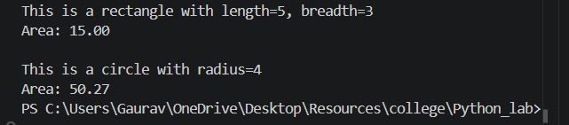
8. Program to calculate area of shapes using inheritance
class Shape:
def area(self):
"""Base method - to be overridden"""
pass
def display(self):
print(f"Shape: {self.__class__.__name__}")
print(f"Area: {self.area()}")
class Rectangle(Shape):
def __init__(self, length, width):
self.length = length
self.width = width
def area(self):
return self.length * self.width
class Square(Rectangle):
def __init__(self, side):
super().__init__(side, side)
class Triangle(Shape):
def __init__(self, base, height):
self.base = base
self.height = height
def area(self):
return 0.5 * self.base * self.height
class Circle(Shape):
def __init__(self, radius):
self.radius = radius
def area(self):
return 3.14159 * self.radius ** 2
print("=== Area Calculator using Inheritance ===")
shapes = [
Rectangle(5, 3),
Square(4),
Triangle(6, 4),
Circle(3)
]
for shape in shapes:
shape.display()
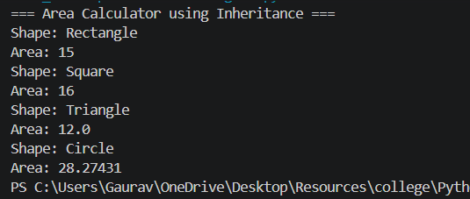
9. Program to demonstrate encapsulation
class BankAccount:
def __init__(self, account_no, holder_name, balance):
self.account_no = account_no # Public
self.holder_name = holder_name # Public
self._branch = "Main Branch" # Protected (convention)
self.__balance = balance # Private (name mangling)
def get_balance(self):
return self.__balance
def deposit(self, amount):
if amount > 0:
self.__balance += amount
print(f"Deposited ₹{amount}. New balance: ₹{self.__balance}")
else:
print("Invalid deposit amount")
def withdraw(self, amount):
if 0 < amount <= self.__balance:
self.__balance -= amount
print(f"Withdrawn ₹{amount}. New balance: ₹{self.__balance}")
else:
print("Invalid withdrawal amount")
def display_info(self):
print(f"Account: {self.account_no}")
print(f"Holder: {self.holder_name}")
print(f"Branch: {self._branch}")
print(f"Balance: ₹{self.__balance}")
acc = BankAccount("SB12345", "Alice Johnson", 5000)
acc.display_info()
print(f"\nAccessing public: {acc.account_no}")
print(f"Accessing protected (convention): {acc._branch}")
# print(acc.__balance) # This will raise AttributeError
print(f"Accessing private via getter: {acc.get_balance()}")
acc.deposit(2000)
acc.withdraw(1000)
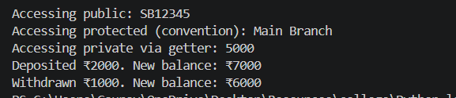
10. Program to demonstrate polymorphism
class Bird:
def sound(self):
return "Some bird sound"
def move(self):
return "Flying"
class Dog:
def sound(self):
return "Woof!"
def move(self):
return "Running"
class Fish:
def sound(self):
return "Blub blub"
def move(self):
return "Swimming"
class Cat:
def sound(self):
return "Meow!"
def move(self):
return "Walking"
def demonstrate_polymorphism(animal):
print(f"{animal.__class__.__name__}:")
print(f" Sound: {animal.sound()}")
print(f" Movement: {animal.move()}")
animals = [Bird(), Dog(), Fish(), Cat()]
for animal in animals:
demonstrate_polymorphism(animal)
print("\n=== Duck Typing (Python's polymorphism style) ===")
print("'If it walks like a duck and quacks like a duck, it's a duck'")
print("Python focuses on behavior, not type.")
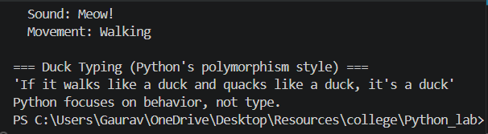
Conclusion:
In this experiment, we studied Object-Oriented Programming concepts in Python including classes and objects, constructors, instance and class variables, single/multiple/multilevel inheritance, method overriding, encapsulation, and polymorphism. OOP enables code reusability, modularity, and better organization of complex programs.

